1. Which UML diagram is shown below?

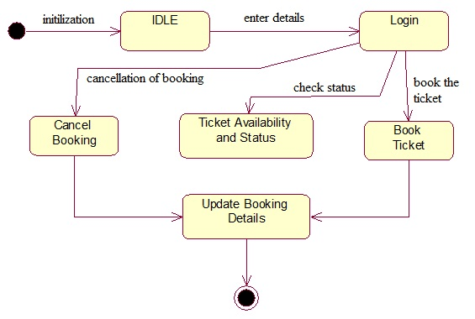

1. Use Case  
   b) State Chart  
   c) Activity  
   d) Object Diagram
2. Which UML diagram is shown below?

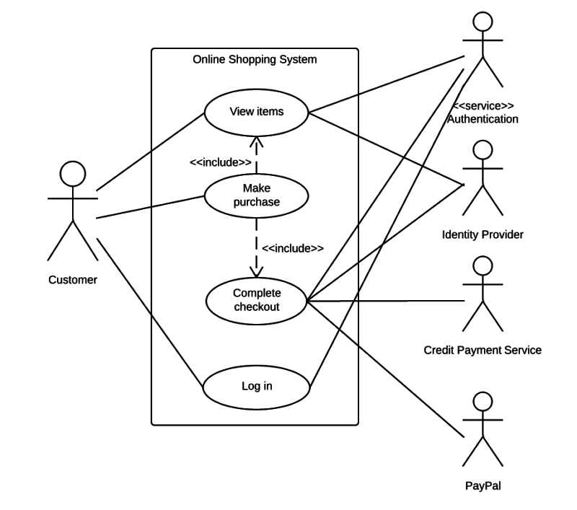

1. Use Case  
   b) State Chart  
   c) Activity  
   d) Object Diagram
2. Which UML diagram is shown below?

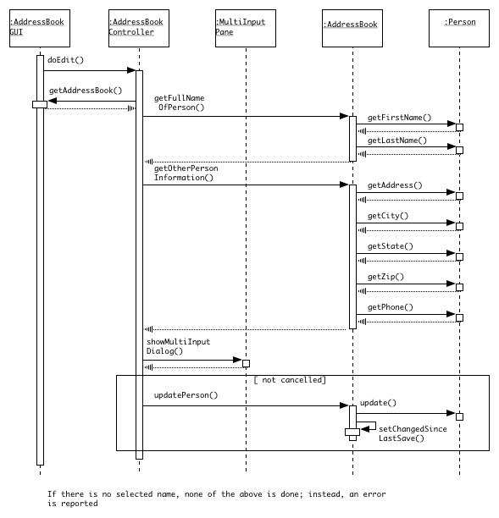

1. Use Case  
   b) State Chart  
   c) Sequence diagram

d) Object Diagram

1. Coupling is a qualitative indication of the degree to which a module  
   a) can be written more compactly  
   b) focuses on just one thing  
   c) is able to complete its function in a timely manner  
   d) is connected to other modules and the outside world
2. Maintenance is the final phase in waterfall model.  
   a) True  
   b) False
3. What do you call a technical person who is capable of understanding the basic requirements?  
   a) team leader  
   b) analyst  
   c) engineer  
   d) stakeholder
4. In which of the following models is the user feedback considered the most valuable?

a)Classical waterfall model

b)Prototyping model

c)Evolutionary model

d)None of the above

68.Which of the following define the characteristic of a good user interface?

a) Speed of learning

b) User guidance and online help

c) Error recovery

d) All of the above

69.Which of the following is not a type of user interface?

a)Command language based

b)Menu based

c)Efficiency based

d)Direct manipulation based

70.Which of the following objectives are not the one that the user interface offers?

(i)Help user interact with the software.

(ii)Give commands and input through the instructions that are displayed via user interface.

(iii)To improve the coding skills of the users.

a) All i, ii and iii are correct

b) Only i and ii are correct

c) Only i and iii are correct

d) None of the given options is correct

71.Concerning software design principles, a UI stands for User Integration

1. True
2. False

72 OOP stands for ...

1. Object-Oriented Programming
2. Object-Oriented Process
3. Both a and b
4. None of these

73 A model that is the demo implementation of the system is

1. Classical Waterfall Model
2. Spiral Model
3. Prototype Model
4. Evolutionary Model

74 GUI stands for

1. Graphics uniform interaction
2. Graphical user interaction
3. Graphical user interface
4. None of the above

75 Which of the following is also called ICONIC interface?

1. Direct Manipulation Interface
2. Manu Based Interface
3. Command Language Based Interface
4. All of these